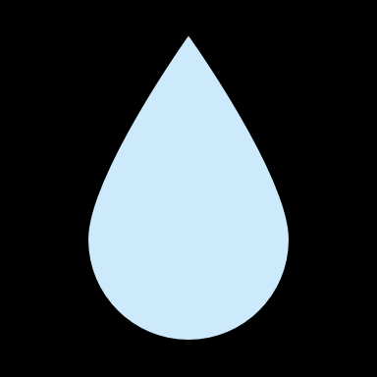
Stormwater Word Search
P | S | E | R | O | S | I | O | N | F | E | U | S | N | C | I | S | H | K | G | S | H | R | C | D | S | M | S
E | B | V | L | S | W | U | X | T | H | G | V | E | T | S | B | T | I | A | E | T | V | T | O | L | P | F | R
H | K | U | H | T | R | K | J | O | C | A | Q | P | J | R | C | Y | U | N | J | O | K | L | Z | R | V | Q | O
M | D | Q | W | R | B | E | R | E | A | G | R | I | V | E | R | P | D | D | H | R | F | R | I | T | E | E | A
F | N | L | E | A | Q | F | P | B | M | A | H | H | D | O | E | R | S | W | U | M | S | E | W | F | L | L | T
U | I | O | Z | R | T | G | M | G | F | Z | U | A | U | B | E | M | G | E | S | W | P | U | D | B | O | F | I
B | M | E | W | C | H | E | S | K | U | Y | P | S | T | R | K | E | W | Q | L | A | J | H | X | N | C | G | G
T | P | S | O | L | N | P | R | O | I | I | K | J | H | G | Q | U | H | T | F | T | D | B | V | N | I | S | U
B | O | K | P | K | C | V | R | S | W | Z | Y | M | C | W | G | Q | N | W | O | E | S | A | C | R | T | V | T
S | L | P | J | U | I | Y | X | Q | H | V | R | G | S | A | E | M | T | N | B | R | V | M | Y | N | Y | S | X
G | L | A | T | L | E | W | J | S | J | E | E | O | H | T | O | S | S | P | A | F | D | S | E | T | Z | C | I
O | U | R | U | S | D | P | M | G | S | E | D | I | M | E | N | T | W | C | G | F | B | I | L | E | G | J | Q
F | T | S | G | A | R | W | A | S | J | L | E | G | G | R | X | E | R | H | I | F | R | J | M | D | O | R | F
E | A | M | O | F | G | R | W | B | P | G | W | G | N | Q | J | I | E | N | H | T | K | S | K | U | W | U | O
A | N | C | F | G | E | A | J | H | K | U | T | B | D | U | F | O | F | D | U | D | I | G | A | P | J | N | L
G | T | D | I | Y | T | F | I | N | F | I | L | T | R | A | T | I | O | N | T | U | R | H | S | A | Z | O | U
A | N | T | S | R | E | A | L | K | B | T | A | R | S | L | D | R | N | M | A | O | Q | K | W | N | J | F | M
Q | O | U | N | F | S | E | O | M | I | R | K | E | V | I | L | S | T | Y | S | G | H | L | B | T | F | F | H
B | A | L | Q | L | R | K | M | Z | Q | O | M | D | B | T | T | K | A | R | N | Y | V | N | F | E | X | K | E
R | E | L | E | O | U | P | I | L | C | R | J | N | B | Y | E | B | O | D | A | P | R | I | R | A | O | T | D
J | K | M | O | O | H | B | A | W | T | U | Z | O | I | W | K | I | A | L | Y | S | C | M | L | M | F | J | W
O | N | P | A | D | E | P | L | G | W | H | K | E | N | F | S | M | N | T | S | T | H | G | O | D | R | A | O
C | X | N | B | T | M | G | E | Z | D | Y | S | P | R | E | C | I | P | I | T | A | T | I | O | N | O | L | B

- CREEK
- EROSION
- FLOOD
- INFILTRATION
- NUTRIENTS
- PADEP
- POLLUTANT
- PRECIPITATION
- RIVER
- RUNOFF
- SEDIMENT
- STORMWATER
- TRASH
- VELOCITY
- WATERSHED
- WATER QUALITY

Precipitation, or stormwater, such as snow and rain seep into the ground or gather on surfaces forming runoff. The runoff then makes its way to our streams and creeks picking up whatever is in its path. If trash is left lying around, the rain will pick it up and carry it into our streams. To keep our water clean, please pick up after yourself!



